Ex. No.: 1) ATM SYSTEM
Date :

Consider any ATM system, design and develop a program in a language of your choice for the same. Create the test cases for the following scenarios:
- Unsuccessful operation due to enter wrong PIN number 3 times.
- Unsuccessful operation due to invalid account type.
- Successful selection of amount to be withdrawn.
- Expected message due to amount to withdraw is greater than possible balance.

IMPLEMENTATION

import java.util.*;
public class ATM
{
public static void main(String[] args) {
int mpin = 1234;
int savbal = 10000;
int currbal = 5000;
Scanner sc = new Scanner(System.in);
int attempt = 0;
do {
if(attempt == 0) {
System.out.println("ATM system - 1NH18CS706\nHello, please enter your PIN");
}
else {
System.out.println("Try again");
}
int pin = sc.nextInt();
if(pin == mpin) {
System.out.println("1) Savings\n2) Current");
int c = sc.nextInt();
switch(c) {
case 1:
int s = 0;
do {
System.out.println("\n1) Check balance\n2) Deposit\n3) Withdraw\n4) Exit\n");
s = sc.nextInt();
switch(s) {
case 1: System.out.println("Balance = Rs. "+savbal);
break;
case 2: System.out.println("Enter amount to deposit: ");
int d = sc.nextInt();
savbal+=d;
System.out.println("Updated balance = Rs. "+savbal);
break;
case 3: System.out.println("Enter amount to withdraw: ");
int w = sc.nextInt();
if(w>savbal) {
System.out.println("Insufficient funds");
}
else {
savbal-=w;
System.out.println("Updated balance = Rs. "+savbal);
}
break;
case 4: System.exit(0);
break;
}
}while(s!=4);
break;
case 2:
int curr = 0;
do {
System.out.println("\n1) Check balance\n2) Deposit\n3) Withdraw\n4) Exit\n");
s = sc.nextInt();
switch(s) {
case 1: System.out.println("Balance = Rs. "+currbal);
break;
case 2: System.out.println("Enter amount to deposit: ");
int d = sc.nextInt();
currbal+=d;
System.out.println("Updated balance = Rs. "+currbal);
break;
case 3: System.out.println("Enter amount to withdraw: ");
int w = sc.nextInt();
if(w>currbal) {
System.out.println("Insufficient funds");
}
else {
currbal-=w;
System.out.println("Updated balance = Rs. "+currbal);
}
break;
case 4: System.exit(0);
break;
}
}while(curr!=4);
break;
}
}attempt++;
}while(attempt<3);
if(attempt==3) {
System.out.println("Invalid PIN entered 3 times, please reinsert your card to proceed");
}
}
}

TEST CASES

TEST CASE 1: Unsuccessful operation due to enter wrong PIN number 3 times.

Project Information |  |  | Test Information
Project Name: | ATM |  | Test Name: |  | Invalid PIN Number
Project ID: | ATM_01 |  | Original Author: |  | Ankit Datta
Test Objective: | This test case is to verify the functionality with invalid pin number
Step No. | Test Case Description | Test Data |  | Expected Result |  | Status  (Pass/Fail) | Remarks
1 | Insert valid card in the insertion point of ATM | Valid ATM card |  | ATM should display language page with following objects English, Kannada, Hindi |  | Pass
2 | Select the preferred language |  |  | ATM should display the PIN number entry screen in selected language |  | Pass
3 | Enter the invalid pin number | Invalid PIN number |  | ATM does not validate PIN and prompts customer to reenter PIN. |  | Pass
4 | Reenter incorrect PIN | Invalid PIN number |  | ATM does not validate PIN and prompts customer to reenter PIN |  | Pass
5 | Reenter incorrect PIN | Invalid PIN number |  | ATM does not validate PIN |  | Pass

TEST CASE 2: Unsuccessful operation due to invalid account type.

Project Information |  |  | Test Information
Project Name: | ATM |  | Test Name: |  | Invalid account type
Project ID: | ATM_02 |  | Original Author: |  | Ankit Datta
Test Objective: | This test case is to verify the functionality with invalid account type.
Step No. | Test Case Description | Test Data |  | Expected Result |  | Status  (Pass/Fail) | Remarks
1 | Insert valid card in the insertion point of ATM | Valid ATM card |  | ATM should display language page with following objects English, Kannada, Hindi |  | Pass
2 | Select the preferred language |  |  | ATM should display the PIN number entry screen in selected language |  | Pass
3 | Enter the valid pin number | valid PIN number |  | ATM validates PIN and prompts customer to choose the account type |  | Pass
4 | Enter invalid account type | Invalid Account Type |  | ATM does not validate the account type which terminates the current process and then  prompts customer to enter the login pin |  | Pass | Enter invalid account type

TEST CASE 3: Successful selection of amount to be withdrawn.

Project Information |  |  | Test Information
Project Name: | ATM |  | Test Name: |  | Selection of amount to be withdrawn
Project ID: | ATM_03 |  | Original Author: |  | Ankit Datta
Test Objective: | This test is to verify the successful selection of amount to be withdrawn
Step No. | Test Case Description | Test Data |  | Expected Result |  | Status  (Pass/Fail) | Remarks
1 | Insert valid card in the insertion point of ATM | Valid ATM card |  | ATM should display language page with following objects English, Kannada, Hindi |  | Pass
2 | Select the preferred language |  |  | ATM should display the PIN number entry screen in selected language |  | Pass
3 | Enter the valid pin number | valid PIN number |  | ATM validates PIN and prompts customer to choose the account type |  | Pass
4 | Enter valid account type | valid Account Type |  | ATM validates the account type and prompts customer to choose the relevant options 1. Check Balance 2. Deposit 3.  Withdrawal 4. Exit |  | Pass
5 | Enter the option | Valid Option to perform withdrawal |  | ATM verifies that the withdrawal amount being lesser than the balance, prompts the  balance amount after the withdrawal |  | Pass

TEST CASE 4: Expected message due to amount to withdraw is greater than possible balance.

Project Information |  |  | Test Information
Project Name: | ATM |  | Test Name: |  | Expected Message due to amount to withdraw is greater than possible balance
Project ID: | ATM_04 |  | Original Author: |  | Ankit Datta
Test Objective: | This test case is to verify the expected message due to amount to withdraw is greater than possible balance.
Step No. | Test Case Description | Test Data |  | Expected Result |  | Status  (Pass/Fail) | Remarks
1 | Insert valid card in the insertion point of ATM | Valid ATM card |  | ATM should display language page with following objects English, Kannada, Hindi |  | Pass
2 | Select the preferred language |  |  | ATM should display the PIN number entry screen in selected language |  | Pass
3 | Enter the valid pin number | valid PIN number |  | ATM validates PIN and prompts customer to choose the account type |  | Pass
4 | Enter valid account type | valid Account Type |  | ATM validates the account type and prompts customer to choose the relevant options 1. Check Balance 2. Deposit 3.  Withdrawal 4. Exit |  | Pass
5 | Enter the option | Valid Option to perform withdrawal |  | ATM verifies that the withdrawal amount being greater than the balance,  prompts the customer with the message “Insufficient Funds” |  | Pass

EXECUTION

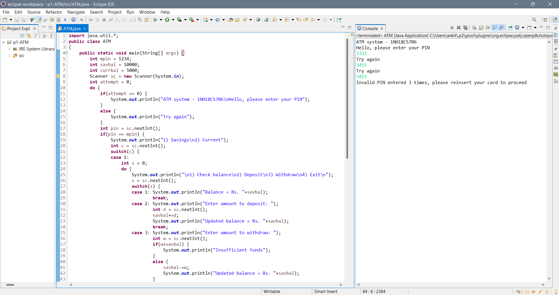

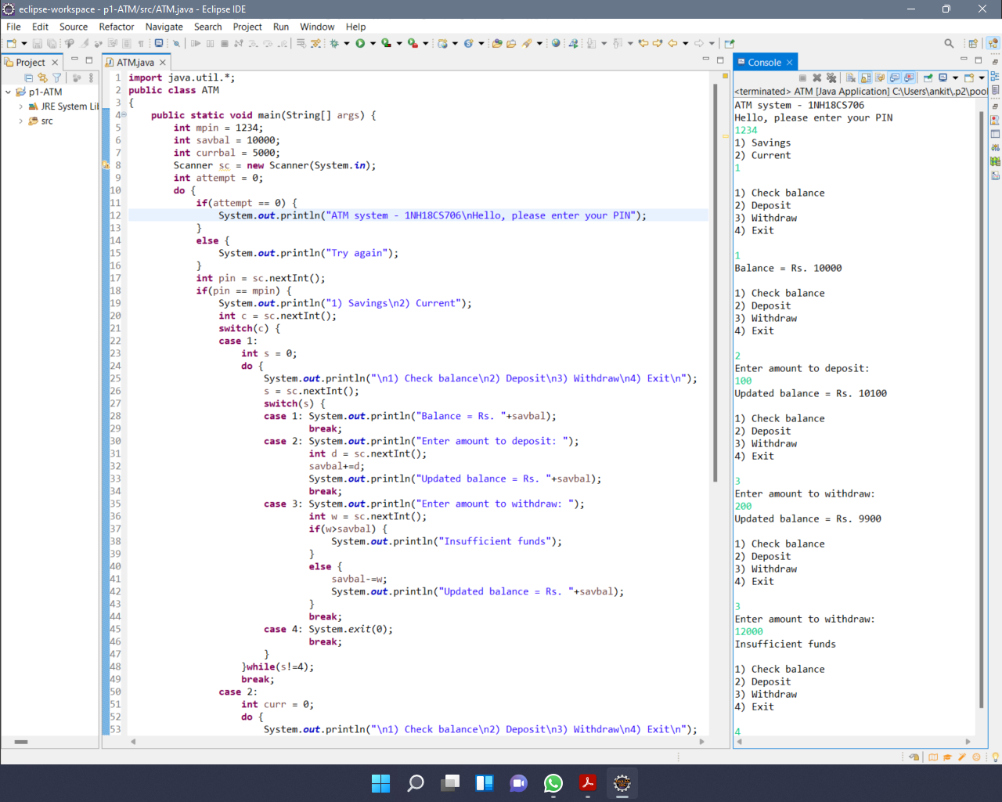

RESULT & DISCUSSION

Test Report:

1. Number of Test Cases Executed : 4
2. Number of Test Cases Passed : 4
3. Number of Test Cases Failed : 0

Ex. No.: 2) TRIANGLE PROBLEM
Date :

Design and develop a program in a language of your choice to solve the triangle problem defined as follows: Accept three integers which are supposed to be the three sides of triangle and determine if the three values represent an equilateral triangle, isosceles triangle, scalene triangle, or they do not form a triangle at all. Create the test cases for the following scenarios:
i) Represents not a triangle
ii) Represents a valid scalene triangle
iii) Represents a valid equilateral triangle
iv) Represents a valid isosceles triangle
Execute the test cases manually and discuss the result.

IMPLEMENTATION

import java.util.Scanner;
public class Tri {
public String check(int a,int b,int c){
if((a>=1 && a<=200) && (b>=1 && b<=200) && (c>=1 && c<=200))
if((a+b>c)&&(b+c>a)&&(c+a>b))
{
if(a==b && b==c) return ("Equilateral");
else if(a==b||b==c||c==a) return ("Isosceles");
else return ("Scalene");
}
else return ("Not a triangle");
return ("Invalid values");
}
public static void main(String[] args)
{
Scanner sc = new Scanner(System.in);
Tri t = new Tri();
System.out.println("1NH18CS706 Ankit Datta");
System.out.println("Enter 3 sides");
int a = sc.nextInt();
int b = sc.nextInt();
int c = sc.nextInt();
System.out.println(t.check(a, b, c));
}
}

TEST CASES

TEST CASE 1: Represents not a triangle

Project Information |  |  | Test Information
Project Name: | Triangle |  | Test Name: |  | Not a triangle
Project ID: | Triangle_01 |  | Original Author: |  | Ankit Datta
Test Objective: | This test case is to verify the scenario which represents not a triangle.
Step No. | Test Case Description | Test Data |  | Expected Result |  | Status (Pass/Fail) | Remarks
1 | Enter invalid sides of a traingle | Invalid data |  | Triangle program prompts the message ‘Not a triangle’ |  | Pass

TEST CASE 2: Represents a valid scalene triangle

Project Information |  |  | Test Information
Project Name: | Triangle |  | Test Name: |  | Valid scalene triangle
Project ID: | Triangle_02 |  | Original Author: |  | Ankit Datta
Test Objective: | This test case is to verify the scenario which represents a Scalene Triangle
Step No. | Test Case Description | Test Data |  | Expected Result |  | Status (Pass/Fail) | Remarks
1 | Enter Valid sides of a triangle | Valid Data |  | TRIANGLE program checks whether the given sides form a Scalene, Equilateral, or Isosceles triangle |  | Pass
2 | All valid sides being unequal | Valid Data |  | TRIANGLE program prompts the user with the message “Scalene” |  | Pass

TEST CASE 3: Represents a valid equilateral triangle

Project Information |  |  | Test Information
Project Name: | Triangle |  | Test Name: |  | Valid equilateral triangle
Project ID: | Triangle_03 |  | Original Author: |  | Ankit Datta
Test Objective: | This test case is to verify the scenario which represents an Equilateral Triangle
Step No. | Test Case Description | Test Data |  | Expected Result |  | Status (Pass/Fail) | Remarks
1 | Enter valid sides of a triangle | Valid Data |  | TRIANGLE program checks whether the given sides form a Scalene, Equilateral or Isosceles triangle |  | Pass
2 | All valid sides being equal | Valid Data |  | TRIANGLE program prompts the user with the message “Equilateral” |  | Pass
TEST CASE 4: Represents a valid isosceles triangle

Project Information |  |  | Test Information
Project Name: | Triangle |  | Test Name: |  | Valid isosceles triangle
Project ID: | Triangle_04 |  | Original Author: |  | Ankit Datta
Test Objective: | This test case is to verify the scenario which represents a Isosceles Triangle
Step No. | Test Case Description | Test Data |  | Expected Result |  | Status (Pass/Fail) | Remarks
1 | Enter Valid sides of a triangle | Valid Data |  | TRIANGLE program checks whether the given sides form a Scalene, Equilateral, or Isosceles triangle |  | Pass
2 | In the valid sides any two being equal | Valid Data |  | TRIANGLE program prompts the user with the message “Isosceles” |  | Pass
EXECUTION

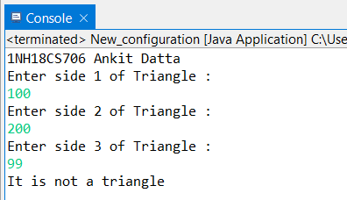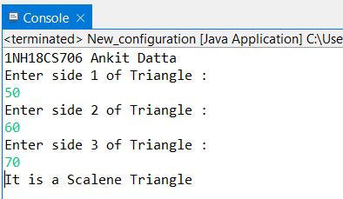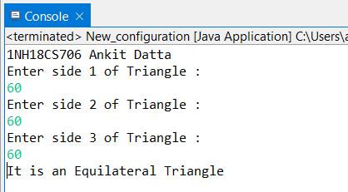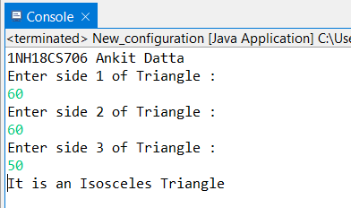

RESULT & DISCUSSION

Test Report:

1. Number of Test Cases Executed : 4
2. Number of Test Cases Passed : 4
3. Number of Test Cases Failed : 0

Ex. No.: 3) BOUNDARY VALUE ANALYSIS (BVA) FOR THE NEXT DATE
Date :

Design, develop, code, and run the program in any suitable language to implement the NextDate function. Analyse it from the perspective boundary value testing. Create different test cases based on the following variants, execute the test cases by using Junit and discuss the test results.
i) Normal Boundary Value Testing
ii) Robust Boundary Value Testing
iii) Worst-Case Boundary Value Testing
iv) Robust Worst-Case Boundary Value Testing

IMPLEMENTATION

public class NextDate {
public static String check(int month, int day, int year)
{
if(day<1 || day>31 || month<1 || month>12 || year<1812 || year>2012)
{
return "Invalid Date";
}
int tom_day = day;
int tom_month = month; int tom_year = year;
if(ThirtyOneday(month))
{
if(day<31) tom_day = day+1; else
{
tom_day = 1; tom_month = month+1;
}
}
else if(Thirtyday(month))
{
if(day<30)
tom_day = day+1;
else if(day==30)
{
tom_day = 1;
tom_month = month+1;
}
else
return “Invalid date”;
}
else if(december(month))
{
if(day<31)
tom_day = day+1;
else
{
tom_day = 1;
tom_month = 1;

if (year==2012)
return "Invalid Date";
else
tom_year=year+1;
}
}
else if(febraury(month))
{
if(day<28)
tom_day = day+1;
else
{
if(day==28)
{
if(leapyear(year))
tom_day=29;
else
{
tom_day = 1;
tom_month = 3;
}
}
else if(day == 29)
{
if(leapyear(year))
{
tom_day = 1;
tom_month = 3;
}
else
return “Invalid Date”;
}
else if(day>29)
return “Invalid Date”;
}
}
return tom_month+”/”+tom_day+”/”+tom_year;
}
private static boolean ThirtyOneday(int month)
{
return month==1 || month==3 || month==5 || month==7 || month==8 || month==10 ;
}
private static boolean Thirtyday(int month)
{
return month==4 || month==6 || month==9 || month==11 ;
}
private static boolean december(int month)
{
return month==12 ;
}
private static boolean febraury(int month)
{
return month==2 ;
}
private static boolean leapyear(int year)
{
if((year%100)==0)
return(year%400==0);
else
return(year%4==0);
}
}

import static org.junit.Assert.*;
import org.junit.Test;
public class NextDate_Test {
// Normal BVA ( 5 out of 13 ) Variation in year ...(min min+ nom max- max) @Test
public void test1() {

assertEquals(NextDate.check(6, 15, 1812),"6/16/1812");
}
@Test
public void test2() {

assertEquals(NextDate.check(6, 15, 1813),"6/16/1813");
}
@Test
public void test3() {

assertEquals(NextDate.check(6, 15, 1912),"6/16/1912");
}
@Test
public void test4() {

assertEquals(NextDate.check(6, 15, 2011),"6/16/2011");
}
@Test
public void test5() {

assertEquals(NextDate.check(6, 15, 2012),"6/16/2012");
}

//Robust BVA ( 7 out of 19 ) Variation in Date ( min- min min+ nominal max- max max+) @Test

public void test6() {

assertEquals(NextDate.check(6, 0, 1912),"Invalid Date");
}
@Test
public void test7() {

assertEquals(NextDate.check(6, 1, 1912),"6/2/1912");
}
@Test
public void test8() {

assertEquals(NextDate.check(6, 2, 1912),"6/3/1912");
}
@Test
public void test9() {

assertEquals(NextDate.check(6, 15, 1912),"6/16/1912");
}
@Test
public void test10() {

assertEquals(NextDate.check(6, 30, 1912),"7/1/1912");
}
@Test
public void test11() {

assertEquals(NextDate.check(6, 31, 1912),"Invalid Date");
}
@Test
public void test12() {

assertEquals(NextDate.check(6, 32, 1912),"Invalid Date");
}

// Worst Case BVA ( 5 out of 125 )

@Test
public void test13() {

assertEquals(NextDate.check(8, 15, 1812),"8/16/1812");
}
@Test
public void test14() {

assertEquals(NextDate.check(8, 15, 1813),"8/16/1813");
}
@Test
public void test15() {

assertEquals(NextDate.check(8, 15, 1912),"8/16/1912");
}
@Test
public void test16() {

assertEquals(NextDate.check(8, 15, 2011),"8/16/2011");
}
@Test
public void test17() {

assertEquals(NextDate.check(8, 15, 2012),"8/16/2012");
}
// worst Case robust bva ( 3 out of 343)

@Test
public void test18() {

assertEquals(NextDate.check(13, 44, 2012),"Invalid Date");
}
@Test
public void test19() {

assertEquals(NextDate.check(1, 44, 2021),"Invalid Date");
}
@Test
public void test20() {

assertEquals(NextDate.check(13, 4, 2100),"Invalid Date");
}
}

TEST CASES

Test Case Name: Equivalence Class testing for next problem
Test Data: Enter the 3 Integer Value (m, d and y)
Pre-condition: month {1<=m<=12}, day {1<=d<=31}, year {1812<=y<=2012} Test Objective: To find the next date to the given valid date.

- TEST CASES FOR NORMAL BOUNDARY VALUE TESTING

Project Information |  |  |  |  | Test Information
Project Name: | NextDate |  |  |  | Project Name: |  |  | NEXT DATE
Project ID: | NextDate_01 |  |  |  | Original Author: |  |  | Ankit Datta
Test  Objective: | Find out the next date for a given date (Normal BVA)
Test Case ID | Test Case Description | Test Data |  |  |  | Expected Result | Status (Pass/ Fail) |  | Remark
Test Case ID | Test Case Description | a | b | c |  | Expected Result |  |  | Remark
NXTDATE2b  _n1 | Enter the nominal values for m& d, y changes | 6 | 15 | 1812 |  | Message must be displayed as “16.6.1812” | Pass
NXTDATE2b  _n2 | Enter the nominal values for m& d, y changes | 6 | 15 | 1813 |  | Message must be displayed as “16.6.1813” | Pass
NXTDATE2b  _n3 | Enter the nominal values for m& d, y changes | 6 | 15 | 1912 |  | Message must be displayed as “16.6.1912” | Pass
NXTDATE2b  _n4 | Enter the nominal values for m& d, y changes | 6 | 15 | 2011 |  | Message must be displayed as “16.6.2011” | Pass
NXTDATE2b  _n5 | Enter the nominal values for m& d, y changes | 6 | 15 | 2012 |  | Message must be displayed as “16.6.2012” | Pass
NXTDATE2b  _n6 | Enter the nominal values for m& y, dchanges | 6 | 1 | 1912 |  | Message must be displayed as “2.6.1912” | Pass
NXTDATE2b  _n7 | Enter the nominal values for m& y, dchanges | 6 | 2 | 1912 |  | Message must be displayed as “3.6.1912” | Pass
NXTDATE2b  _n8 | Enter the nominal values for m& y, dchanges | 6 | 30 | 1912 |  | Message must be displayed as “1.7.1912” | Pass
NXTDATE2b  _n9 | Enter the nominal values for m& y, dchanges | 6 | 31 | 1912 |  | Message must be displayed as “Invalid values” | Pass
NXTDATE2b  _n10 | Enter the nominal values for m changes, d,&y | 1 | 15 | 1912 |  | Message must be displayed as “16.1.1912” | Pass
NXTDATE2b  _n11 | Enter the nominal values for m changes, d,&y | 2 | 15 | 1912 |  | Message must be displayed as “16.2.1912” | Pass
NXTDATE2b  _n12 | Enter the nominal values for m changes, d,&y | 11 | 15 | 1912 |  | Message must be displayed as “16.11.1912” | Pass
NXTDATE2b  _n13 | Enter the nominal values for m changes, d,&y | 12 | 15 | 1912 |  | Message must be displayed as “16.12.2012” | Pass

- TEST CASES FOR ROBUST BOUNDARY VALUE TESTING

Project Information |  |  |  |  | Test Information
Project Name: | NextDate |  |  |  | Project Name: |  |  | NEXT DATE
Project ID: | NextDate_02 |  |  |  | Original Author: |  |  | Ankit Datta
Test  Objective: | Find out the next date for a given date (Robust BVA)
Test Case ID | Test Case Description | Test Data |  |  |  | Expected Result | Status (Pass/ Fail) |  | Remark
Test Case ID | Test Case Description | a | b | c |  | Expected Result |  |  | Remark
NXTDATE2b  _n1 | Enter the nominal values for m& d, y  changes | 6 | 15 | 1811 |  | Message must be displayed as “Invalid Date” | Pass
NXTDATE2b  _n2 | Enter the nominal values for m& d, y changes | 6 | 15 | 1812 |  | Message must be displayed as “16.6.1812” | Pass
NXTDATE2b  _n3 | Enter the nominal values for m& d, y changes | 6 | 15 | 1813 |  | Message must be displayed as “16.6.1813” | Pass
NXTDATE2b  _n4 | Enter the nominal values for m& d, y changes | 6 | 15 | 1912 |  | Message must be displayed as “16.6.1912” | Pass
NXTDATE2b  _n5 | Enter the nominal values for m& d, y changes | 6 | 15 | 2011 |  | Message must be displayed as “16.6.2011” | Pass
NXTDATE2b  _n6 | Enter the nominal values for m& d, y changes | 6 | 15 | 2012 |  | Message must be displayed as “16.6.2012” | Pass
NXTDATE2b  _n7 | Enter the nominal values for m& d, y changes | 6 | 15 | 201  3 |  | Message must be displayed as “Invalid Date” | Pass
NXTDATE2b  _n8 | Enter the nominal values for m& y, dchanges | 6 | 0 | 191  2 |  | Message must be displayed as “Invalid Date” | Pass
NXTDATE2b  _n9 | Enter the nominal values for m& y, dchanges | 6 | 1 | 191  2 |  | Message must be displayed as “2.6.1912” | Pass
NXTDATE2b  _n10 | Enter the nominal values for m& y, dchanges | 6 | 2 | 191  2 |  | Message must be displayed as “3.6.1912” | Pass
NXTDATE2b  _n11 | Enter the nominal values for m& y, dchanges | 6 | 30 | 191  2 |  | Message must be displayed as “1.7.1912” | Pass
NXTDATE2b  _n12 | Enter the nominal values for m& y, dchanges | 6 | 31 | 191  2 |  | Message must be displayed as “Invalid Date” | Pass
NXTDATE2b  _n13 | Enter the nominal values for m& y, dchanges | 6 | 32 | 191  2 |  | Message must be displayed as “Invalid Date” | Pass
NXTDATE2b  _n14 | Enter the nominal values for m changes, d,&y | 0 | 15 | 191  2 |  | Message must be displayed as “Invalid Date” | Pass
NXTDATE2b  _n15 | Enter the nominal values for m changes, d,&y | 1 | 15 | 191  2 |  | Message must be displayed as “16.1.1912” | Pass
NXTDATE2b  _n16 | Enter the nominal values for m changes, d,&y | 2 | 15 | 191  2 |  | Message must be displayed as “16.2.1912” | Pass
NXTDATE2b  _n17 | Enter the nominal values for m changes, d,&y | 11 | 15 | 191  2 |  | Message must be displayed as “16.11.1912” | Pass
NXTDATE2b  _n18 | Enter the nominal values for m changes, d,&y | 12 | 15 | 191  2 |  | Message must be displayed as “16.12.2012” | Pass
NXTDATE2b  _n19 | Enter the nominal values for m changes, d,&y | 13 | 15 | 191  2 |  | Message must be displayed as “Invalid Date” | Pass

- TEST CASES FOR WORST-CASE BOUNDARY VALUE TESTING

Project Information |  |  |  |  | Test Information
Project Name: | NextDate |  |  |  | Project Name: |  |  | NEXT DATE
Project ID: | NextDate_03 |  |  |  | Original Author: |  |  | Ankit Datta
Test  Objective: | Find out the next date for a given date (Normal BVA)
Test Case ID | Test Case Description | Test Data |  |  |  | Expected Result | Status (Pass/ Fail) |  | Remark
Test Case ID | Test Case Description | a | b | c |  | Expected Result |  |  | Remark
NXTDATE2b  _n1 | Enter the nominal  values for m& d, y changes | 1 | 1 | 1822 |  | Message must be displayed as “2.1.1812” | Pass
NXTDATE2b  _n2 | Enter the nominal values for m& d, y changes | 1 | 1 | 1813 |  | Message must be displayed as “2.1.1813” | Pass
NXTDATE2b  _n3 | Enter the nominal values for m& d, y changes | 1 | 1 | 1912 |  | Message must be displayed as “2.1.1912” | Pass
NXTDATE2b  _n4 | Enter the nominal values for m& d, y changes | 1 | 1 | 2011 |  | Message must be displayed as “2.1.2011” | Pass
NXTDATE2b  _n5 | Enter the nominal values for m& d, y changes | 1 | 1 | 2012 |  | Message must be displayed as “2.1.2012” | Pass
NXTDATE2b  _n6 | Enter the nominal values for m& d, y changes | 1 | 2 | 1812 |  | Message must be displayed as “3.1.1912” | Pass
NXTDATE2b  _n7 | Enter the nominal values for m& d, y changes | 1 | 2 | 1813 |  | Message must be displayed as “3.1.1912” | Pass
NXTDATE2b  _n8 | Enter the nominal values for m& y, d changes | 1 | 2 | 1912 |  | Message must be displayed as “3.1.1912” | Pass
NXTDATE2b  _n9 | Enter the nominal values for m& y, d changes | 1 | 2 | 2011 |  | Message must be displayed as “3.1.2011” | Pass
NXTDATE2b  _n10 | Enter the nominal values for m& y, d changes | 1 | 2 | 2012 |  | Message must be displayed as “3.1.2012” | Pass
NXTDATE2b  _n11 | Enter the nominal values for m& y, d changes | 1 | 15 | 1812 |  | Message must be displayed as “16.1.1812” | Pass
NXTDATE2b  _n12 | Enter the nominal values for m& y, dchanges | 1 | 15 | 1813 |  | Message must be displayed as “16.1.1813” | Pass
NXTDATE2b  _n13 | Enter the nominal values for m changes, d,&y | 12 | 15 | 1912 |  | Message must be displayed as “16.12.1912” | Pass
NXTDATE2b  _n14 | Enter the nominal values for m& y, dchanges | 1 | 15 | 1912 |  | Message must be displayed as “16.1.1912” | Pass
NXTDATE2b  _n15 | Enter the nominal values for m changes, d,&y | 1 | 15 | 2011 |  | Message must be displayed as “16.1.2011” | Pass
NXTDATE2b  _n16 | Enter the nominal values for m changes, d,&y | 1 | 15 | 2012 |  | Message must be displayed as “16.1.2012” | Pass
NXTDATE2b  _n17 | Enter the nominal values for m changes, d,&y | 1 | 30 | 1812 |  | Message must be displayed as “31.1.1812” | Pass
NXTDATE2b  _n178 | Enter the nominal values for m changes, d,&y | 1 | 30 | 1813 |  | Message must be displayed as “31.1.1813” | Pass
NXTDATE2b  _n19 | Enter the nominal values for m changes, d,&y | 1 | 30 | 1912 |  | Message must be displayed as “31.1.1912” | Pass
NXTDATE2b  _n20 | Enter the nominal values for m changes, d,&y | 1 | 30 | 2011 |  | Message must be displayed as “31.1.2011” | Pass

- TEST CASES FOR ROBUST WORST-CASE BOUNDARY VALUE TESTING

Project Information |  |  |  |  | Test Information
Project Name: | NextDate |  |  |  | Project Name: |  |  | NEXT DATE
Project ID: | NextDate_04 |  |  |  | Original Author: |  |  | Ankit Datta
Test  Objective: | Find out the next date for a given date (Robust Worst-Case BVA)
Test Case ID | Test Case Description | Test Data |  |  |  | Expected Result | Status (Pass/ Fail) |  | Remark
Test Case ID | Test Case Description | a | b | c |  | Expected Result |  |  | Remark
NXTDATE2b  _n1 | Enter the nominal  values for m& d, y changes | 1 | 0 | 1811 |  | Message must be displayed as “Invalid Date” | Pass
NXTDATE2b  _n2 | Enter the nominal values for m& d, y changes | 0 | 0 | 1812 |  | Message must be displayed as “Invalid Date” | Pass
NXTDATE2b  _n3 | Enter the nominal values for m& d, y changes | 0 | 1 | 2013 |  | Message must be displayed as “Invalid Date” | Pass
NXTDATE2b  _n4 | Enter the nominal values for m& d, y changes | 1 | 1 | 1812 |  | Message must be displayed as “2.1.1812” | Pass
NXTDATE2b  _n5 | Enter the nominal values for m& d, y changes | 1 | 1 | 1813 |  | Message must be displayed as “2.1.1813” | Pass
NXTDATE2b  _n6 | Enter the nominal values for m& d, y changes | 1 | 1 | 1912 |  | Message must be displayed as “2.1.1912” | Pass
NXTDATE2b  _n7 | Enter the nominal values for m& d, y changes | 1 | 1 | 2011 |  | Message must be displayed as “2.1.2011” | Pass
NXTDATE2b  _n8 | Enter the nominal values for m& d, y changes | 1 | 1 | 2012 |  | Message must be displayed as “2.1.2012” | Pass
NXTDATE2b  _n9 | Enter the nominal values for m& d, y changes | 1 | -1 | 1811 |  | Message must be displayed as “Invalid Date” | Pass
NXTDATE2b  _n10 | Enter the nominal values for m& d, y changes | -1 | -1 | 1812 |  | Message must be displayed as “Invalid Date” | Pass
NXTDATE2b  _n10 | Enter the nominal values for m& d, y changes | -1 | 2 | 181  1 |  | Message must be displayed as “Invalid Date” | Pass
NXTDATE2b  _n11 | Enter the nominal values for m& y, dchanges | 1 | 2 | 191  2 |  | Message must be displayed as “3.1.1912” | Pass
NXTDATE2b  _n12 | Enter the nominal values for m changes, d,&y | 12 | 15 | 1912 |  | Message must be displayed as “16.12.1912” | Pass
NXTDATE2b  _n13 | Enter the nominal values for m& y, dchanges | 1 | 2 | 2012 |  | Message must be displayed as “3.1.2012” | Pass
NXTDATE2b  _n14 | Enter the nominal values for m& y, dchanges | 1 | 15 | 1812 |  | Message must be displayed as “16.1.1812” | Pass
NXTDATE2b  _n15 | Enter the nominal values for m& y, dchanges | 1 | 15 | 1813 |  | Message must be displayed as “16.1.1813” | Pass
NXTDATE2b  _n16 | Enter the nominal values for m& y, dchanges | 1 | 15 | 1912 |  | Message must be displayed as “16.1.1912” | Pass
NXTDATE2b  _n17 | Enter the nominal values for m changes, d,&y | 1 | 15 | 2011 |  | Message must be displayed as “16.1.2011” | Pass
NXTDATE2b  _n18 | Enter the nominal values for m changes, d,&y | 1 | 15 | 2012 |  | Message must be displayed as “16.1.2012” | Pass
NXTDATE2b  _n19 | Enter the nominal values for m changes, d,&y | 1 | 30 | 1812 |  | Message must be displayed as “31.1.1812” | Pass

EXECUTION

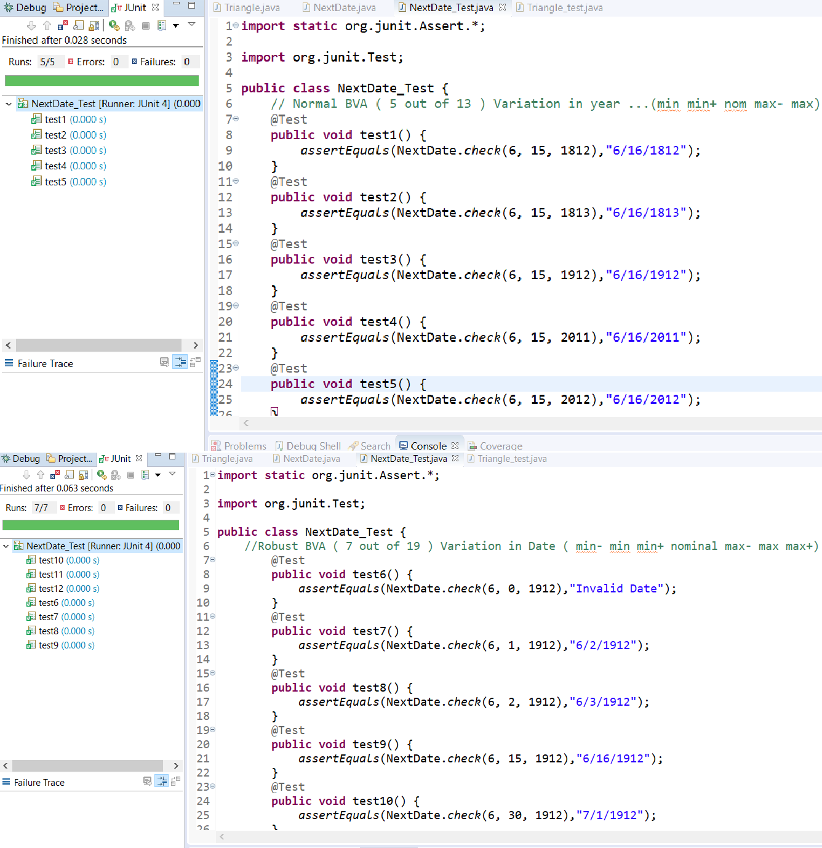
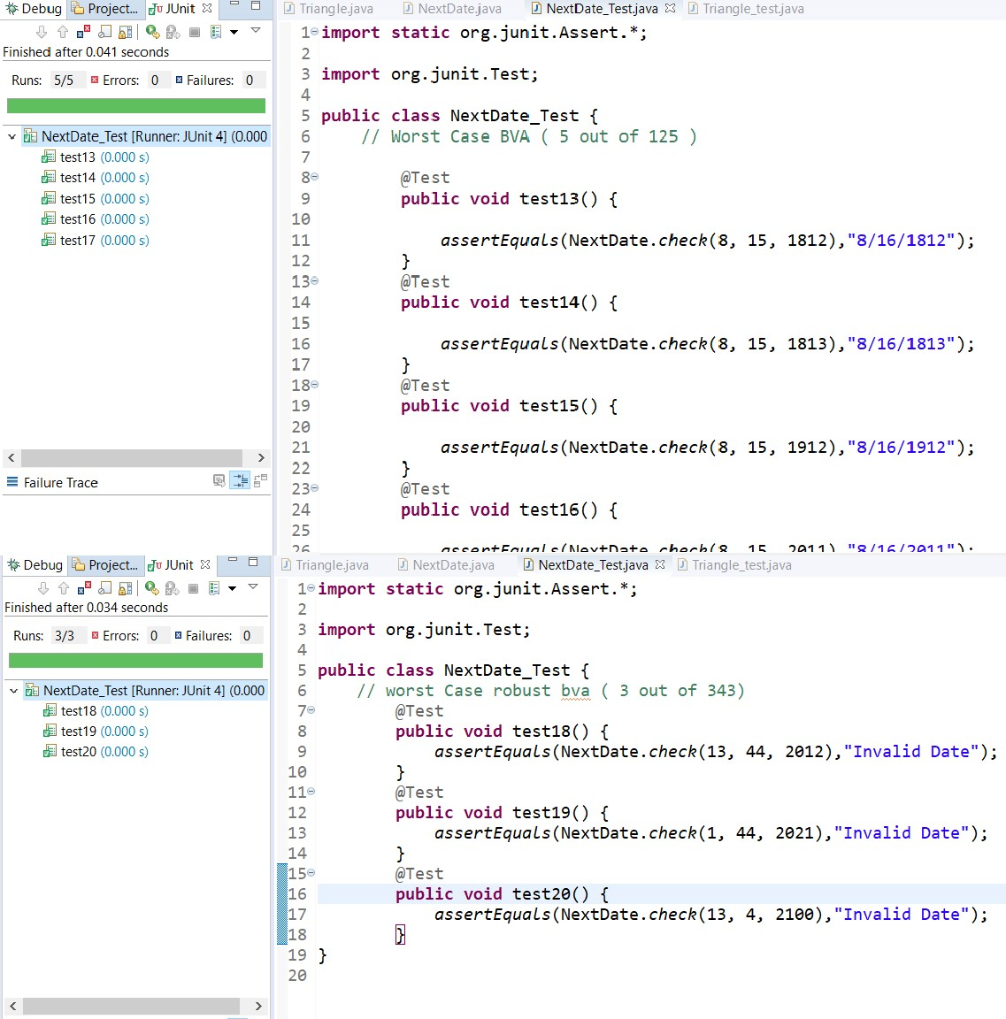

RESULT & DISCUSSION

Test Report:

1. Number of Test Cases Executed : 20
2. Number of Test Cases Passed : 20
3. Number of Test Cases Failed : 0

Ex. No.: 4) EQUIVALENCE CLASS PARTITIONING (ECP) FOR THE NEXT DATE
Date :

Design, develop, code and run the program in any suitable language to implement the NextDate function. Analyse it from the perspective equivalence class testing. Create different test cases, execute these test cases by using JUnit and discuss the test results.
i) Weak Normal Equivalence Class Testing
ii) Strong Normal Equivalence Class Testing
iii) Weak Robust Equivalence Class Testing
iv) Strong Robust Equivalence Class Testing

IMPLEMENTATION

public class nextdate
{
public static String next(int d, int m, int y, int cc)
{
if(d==cc)
{
d=1;
if(m==12)
{
y++;
m=1;
}
else
{
m++;
}
}
else
{
d++;
}
return(String.valueOf(d)+"/"+String.valueOf(m)+"/"+String.valueOf(y));
}
public String nextday(int d, int m, int y)
{
if(d>=1 && d<=31 && m>=1 && m<=12 && y>=1812 && y<=2012)
{
switch(m)
{
case 1:
case 3:return(next(d,m,y,31));
case 5:return(next(d,m,y,31));
case 7:return(next(d,m,y,31));
case 8:return(next(d,m,y,31));
case 10:return(next(d,m,y,31));
case 12: return(next(d,m,y,31));
case 4: return(next(d,m,y,30));
case 6: return(next(d,m,y,30));
case 9: return(next(d,m,y,30));
case 11: return(next(d,m,y,30));
default: return(next(d,m,y,((y%4==0 && y%100!=0) || y%400==0)?29:28));
}
}
return "Invalid Values";
}
}

Junit Code

package nd2;
import static org.junit.Assert.*;
import org.junit.Test;
public class equind2pgm {
//weak and strong normal test case
@Test
public void test_1()
{
nextdate ob1=new nextdate();
assertEquals(ob1.nextday(15,6,1912),"16/6/1912");
}
@Test
public void test_2()
{
nextdate ob1=new nextdate();
assertEquals(ob1.nextday(10,6,1912),"11/6/1912");
}
@Test
public void test_3()
{
nextdate ob1=new nextdate();
assertEquals(ob1.nextday(10,6,1900),"11/6/1900");
}
@Test
public void test_4()
{
nextdate ob1=new nextdate();
assertEquals(ob1.nextday(10,5,1912),"11/5/1912");
}
@Test
public void test_5()
{
nextdate ob1=new nextdate();
assertEquals(ob1.nextday(20,10,2010),"21/10/2010");
}
//weak robust test cases
@Test
public void test3()
{
nextdate ob1=new nextdate();
assertEquals(ob1.nextday(-1,10,1912),"Invalid Values");
}
@Test
public void test31()
{
nextdate ob1=new nextdate();
assertEquals(ob1.nextday(12,7,1912),"13/7/1912");
}
@Test
public void test32()
{
nextdate ob1=new nextdate();
assertEquals(ob1.nextday(12,8,1912),"13/8/1912");
}
@Test
public void test33()
{
nextdate ob1=new nextdate();
assertEquals(ob1.nextday(12,4,1912),"13/4/1912");
}
@Test
public void test34()
{
nextdate ob1=new nextdate();
assertEquals(ob1.nextday(12,9,1912),"13/9/1912");
}
@Test
public void test35()
{
nextdate ob1=new nextdate();
assertEquals(ob1.nextday(12,1,1912),"13/1/1912");
}
@Test
public void test36()
{
nextdate ob1=new nextdate();
assertEquals(ob1.nextday(12,2,1912),"13/2/1912");
}
@Test
public void test37()
{
nextdate ob1=new nextdate();
assertEquals(ob1.nextday(12,3,1912),"13/3/1912");
}
@Test
public void test30()
{
nextdate ob1=new nextdate();
assertEquals(ob1.nextday(10,3,1912),"11/3/1912");
}
@Test
public void test4()
{
nextdate ob1=new nextdate();
assertEquals(ob1.nextday(15,13,1912),"Invalid Values");
}
@Test
public void test5()
{
nextdate ob1=new nextdate();
assertEquals(ob1.nextday(1,6,2200),"Invalid Values");
}
@Test
public void test6()
{
nextdate ob1=new nextdate();
assertEquals(ob1.nextday(32,6,1912),"Invalid Values");
}
@Test
public void test7()
{
}
@Test
nextdate ob1=new nextdate();
assertEquals(ob1.nextday(15,6,1811),"Invalid Values");
public void test8()
{
nextdate ob1=new nextdate();
assertEquals(ob1.nextday(15,6,2013),"Invalid Values");
}
//strong robust test cases @Test
public void test9()
{
nextdate ob1=new nextdate();
assertEquals(ob1.nextday(2,1,1912),"3/1/1912");
}
@Test
public void test10()
{
nextdate ob1=new nextdate();
assertEquals(ob1.nextday(-1,3,1900),"Invalid Values");
}
@Test
public void test11()
{
nextdate ob1=new nextdate();
assertEquals(ob1.nextday(15,0,1811),"Invalid Values");
}
@Test
public void test12()
{
nextdate ob1=new nextdate();
assertEquals(ob1.nextday(33,12,1912),"Invalid Values");
}
@Test
public void test13()
{
}
@Test
nextdate ob1=new nextdate();
assertEquals(ob1.nextday(15,-1,-1),"Invalid Values");
public void test14()
{
nextdate ob1=new nextdate();
assertEquals(ob1.nextday(-1,6,-1),"Invalid Values");
}
@Test
public void test15()
{
nextdate ob1=new nextdate();
assertEquals(ob1.nextday(-1,-1,-1),"Invalid Values");
}
@Test
public void test16()
{
nextdate ob1=new nextdate();
assertEquals(ob1.nextday(31,12,2010),"1/1/2011");
}
@Test
public void test17()
{
nextdate ob1=new nextdate();
assertEquals(ob1.nextday(30,11,2010),"1/12/2010");
}
//////leap @Test
public void test18()
{
nextdate ob1=new nextdate();
assertEquals(ob1.nextday(3,2,2010),"4/2/2010");
}
@Test
public void test19()
{
nextdate ob1=new nextdate();
assertEquals(ob1.nextday(28,2,2010),"1/3/2010");
}
@Test
public void test20()
{
nextdate ob1=new nextdate();
assertEquals(ob1.nextday(20,2,2008),"21/2/2008");
}
@Test
public void test21()
{
nextdate ob1=new nextdate();
assertEquals(ob1.nextday(29,2,2000),"1/3/2000");
}
@Test
public void test22()
{
nextdate ob1=new nextdate();
assertEquals(ob1.nextday(28,2,1900),"1/3/1900");
}
}

TEST CASES

Test Case Name: Equivalence Class testing for next problem
Test Data: Enter the 3 Integer Value (m, d and y)
Pre-condition: month{1<=m<=12}, day{1<=d<=31}, year{1812<=y<=2012}
Test Objective: To find the next date to the given valid date.

- TEST CASES FOR WEAK NORMAL EQUIVALENCE CLASS TESTING

Project Information |  |  |  |  | Test Information
Project Name: | NEXTDATE |  |  |  | Project Name: |  |  | NEXTDATE
Project ID: | NEXTDATE_01 |  |  |  | Original Author: |  |  | Ankit Datta
Test  Objective: | Check if valid date input gives next date (Weak normal equivalence class testing)
Test Case ID | Test Case Description | Test Data |  |  |  | Expected Result | Status (Pass/ Fail) |  | Remark
Test Case ID | Test Case Description | m | d | y |  | Expected Result |  |  | Remark
TEST2d_wn1 | Enter the values for m, d, y arbitrarily chosen from equivalence class | 6 | 14 | 2000 |  | Message must be displayed as “15.6.2000” | Pass

- TEST CASES FOR STRONG NORMAL EQUIVALENCE CLASS TESTING

Project Information |  |  |  |  | Test Information
Project Name: | NEXTDATE |  |  |  | Project Name: |  |  | NEXTDATE
Project ID: | NEXTDATE_02 |  |  |  | Original Author: |  |  | Ankit Datta
Test  Objective: | Check if valid date input gives next date (Weak normal equivalence class testing)
Test Case ID | Test Case Description | Test Data |  |  |  | Expected Result | Status (Pass/ Fail) |  | Remark
Test Case ID | Test Case Description | m | d | y |  | Expected Result |  |  | Remark
TEST2d_wn1 | Enter the values for m, d, y arbitrarily chosen from equivalence class | 6 | 19 | 2000 |  | Message must be displayed as “20.6.2000” | Pass
TEST2d_wn2 | Enter the values for m, d, y arbitrarily chosen from equivalence class | 7 | 31 | 1956 |  | Message must be displayed as “1.8.1957” | Pass

- TEST CASES FOR WEAK ROBUST EQUIVALENCE CLASS TESTING

Project Information |  |  |  |  | Test Information
Project Name: | NEXTDATE |  |  |  | Project Name: |  |  | NEXTDATE
Project ID: | NEXTDATE_03 |  |  |  | Original Author: |  |  | Ankit Datta
Test  Objective: | Check if valid date input gives next date (Weak normal equivalence class testing)
Test Case ID | Test Case Description | Test Data |  |  |  | Expected Result | Status (Pass/ Fail) |  | Remark
Test Case ID | Test Case Description | m | d | y |  | Expected Result |  |  | Remark
TEST2d_wn1 | Enter the values for m, d, y arbitrarily chosen from equivalence class | 31 | 14 | 2000 |  | Message must be displayed as not a valid date | Pass

- TEST CASES FOR STRONG ROBUST EQUIVALENCE CLASS TESTING

Project Information |  |  |  |  | Test Information
Project Name: | NEXTDATE |  |  |  | Project Name: |  |  | NEXTDATE
Project ID: | NEXTDATE_04 |  |  |  | Original Author: |  |  | Ankit Datta
Test  Objective: | Check if valid date input gives next date (Weak normal equivalence class testing)
Test Case ID | Test Case Description | Test Data |  |  |  | Expected Result | Status (Pass/ Fail) |  | Remark
Test Case ID | Test Case Description | m | d | y |  | Expected Result |  |  | Remark
TEST2d_wn1 | Enter the values for m, d, y arbitrarily chosen from equivalence class | 13 | 35 | 2000 |  | Message must be displayed as not a valid date | Pass
TEST2d_wn1 | Enter the values for m, d, y arbitrarily chosen from equivalence class | -1 | 49 | 2000 |  | Message must be displayed as not a valid date | Pass

EXECUTION

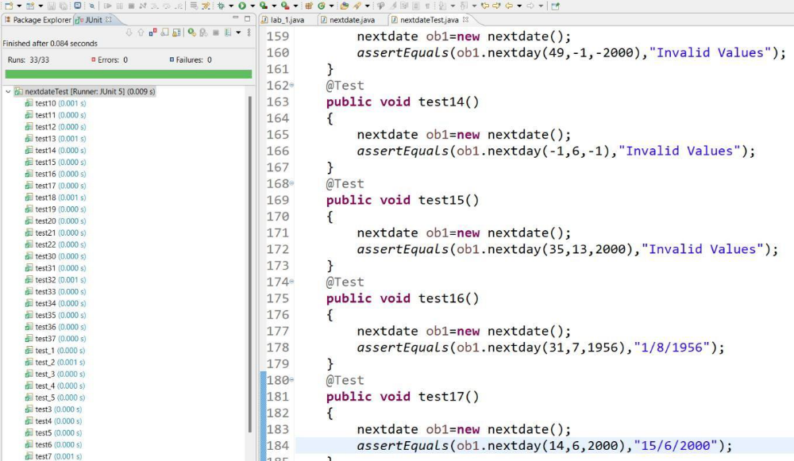

RESULT & DISCUSSION

Test Report:

1. Number of Test Cases Executed : 33
2. Number of Test Cases Passed : 33
3. Number of Test Cases Failed : 0

Ex. No.: 5) DEMONSTRATION OF WHITE BOX TESTING TECHNIQUE USING ECLEMMA
Date :

Demonstrate white box testing techniques using open-source testing tool JUnit and ECLEMMA. Implement and execute test cases for achieving full statement coverage, decision/branch coverage and condition coverage for the triangle problem.

IMPLEMENTATION

public class tri {
public String op(int a,int b, int c){

int o=1;
do{
if(a>=1 && a<=200 && b>=1 && b<=200 && c>=1 && c<=200)
{
if(a<b+c && b<c+a && c<a+b )
{
if(a==b && b==c){
return("Equilateral Triangle");
}
else if(a==b ||b==c || c==a ){
return("Isosceles Triangle");
}
else{
return("Scalene Triangle");
}
}
else{
return("Not a Triangle");
}
}
else{
return("Invalid");
}
}while(o!=2);

}
}

Junit:

import static org.junit.Assert.*;

import org.junit.Test;

public class triTC {

@Test
public void test() {
tri t1=new tri();
assertEquals(t1.op(2, 2, 5),"Not a Triangle");
}
@Test
public void test12() {
tri t1=new tri();
assertEquals(t1.op(1, 8, 1),"Not a Triangle");
}
@Test
public void test13() {
tri t1=new tri();
assertEquals(t1.op(2, 3, 7),"Not a Triangle");
}

@Test
public void test1() {
tri t1=new tri();
assertEquals(t1.op(3, 3, 3),"Equilateral Triangle");
}

@Test
public void test2() {
tri t1=new tri();
assertEquals(t1.op(4, 5, 3),"Scalene Triangle");
}
@Test
public void test3() {
tri t1=new tri();
assertEquals(t1.op(6, 8, 6),"Isosceles Triangle");
}
@Test
public void test4() {
tri t1=new tri();
assertEquals(t1.op(0, 1, 5),"Invalid");
}
@Test
public void test51() {
tri t1=new tri();
assertEquals(t1.op(3, 3, 4),"Isosceles Triangle");
}
@Test
public void test52() {
tri t1=new tri();
assertEquals(t1.op(9, 9, 5),"Isosceles Triangle");
}
@Test
public void test5() {
tri t1=new tri();
assertEquals(t1.op(1, 2, 2),"Isosceles Triangle");
}

@Test
public void test7() {
tri t1=new tri();
assertEquals(t1.op(4, 7, 201),"Invalid");
}

}

EXECUTION

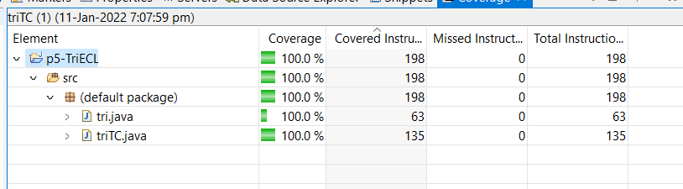

TEST CASES FOR TRIANGLE PROGRAM
Project Information |  |  |  |  | Test Information
Project Name: | TRIANGLE |  |  |  | Project Name: |  | TRIANGLE
Project ID: | TRIANGLE_01 |  |  |  | Original Author: |  | Ankit Datta
Test  Objective: | Check whether given value for a equilateral, isosceles, Scalene triangle or can't from a  triangle
Test Case ID | Test Case Description | Test Data |  |  |  | Expected Result | Status  (Pass/ Fail) | Remark
Test Case ID | Test Case Description | a | b | c |  | Expected Result | Status  (Pass/ Fail) | Remark
TEST2c_1 | Enter the values for a, b, c arbitrarily chosen from equivalenceclass | 5 | 5 | 5 |  | Message must be displayed as “the triangle is Equilateral” | Pass
TEST2c_2 | Enter the values for a, b, c arbitrarily chosen from equivalenceclass | 2 | 2 | 3 |  | Message must be displayed as “the triangle is Isosceles” | Pass
TEST2c_3 | Enter the values for a, b, c arbitrarily chosen from equivalenceclass | 3 | 4 | 5 |  | Message must be displayed as “the triangle is Scalene” | Pass
TEST2c_4 | Enter the values for a, b, c arbitrarily chosen from equivalenceclass | 4 | 1 | 3 |  | Message must be displayed as “Not a Triangle” | Pass

RESULT & DISCUSSION

Thus, the above programs are written and executed using JUnit and ECLEMMA, and 100% coverage is achieved.
Ex. No.: 6) DEMONSTRATION OF WHITE BOX TESTING TECHNIQUE USING ECLEMMA
Date :

Demonstrate white box testing techniques using open-source testing tool JUnit and ECLEMMA. Implement and execute test cases for achieving full statement coverage, decision/branch coverage and condition coverage for the Next Date function.

IMPLEMENTATION

JAVA SCRIPT:

package p6;
public class nextDate {
public static String next(int d, int m, int y, int cc)
{
if(d==cc)
{
d=1;
if(m==12)
{
y++;
m=1;
}
else
{
m++;
}
}
else
{
d++;
}

return(String.valueOf(d)+"/"+String.valueOf(m)+"/"+String.valueOf(y));
}
public String nextday(int d, int m, int y)
{
if(d>=1 && d<=31 && m>=1 && m<=12 && y>=1812 && y<=2012)
{
switch(m)
{
case 1:
case 3:return(next(d,m,y,31));
case 5:return(next(d,m,y,31));
case 7:return(next(d,m,y,31));
case 8:return(next(d,m,y,31));
case 10:return(next(d,m,y,31));
case 12: return(next(d,m,y,31));
case 4: return(next(d,m,y,30));
case 6: return(next(d,m,y,30));
case 9: return(next(d,m,y,30));
case 11: return(next(d,m,y,30));
default: return(next(d,m,y,((y%4==0 && y%100!=0) || y%400==0)?29:28));
}
}
return "Invalid Values";
}
}

JUNIT:

package p6;
import static org.junit.Assert.*;
import org.junit.Test;
public class nextDateECT {
//weak and strong normal test case
@Test
public void test_1()
{
nextDate ob1=new nextDate();
assertEquals(ob1.nextday(15,6,1912),"16/6/1912");
}
@Test
public void test_2()
{
nextDate ob1=new nextDate();
assertEquals(ob1.nextday(10,6,1912),"11/6/1912");
}
@Test
public void test_3()
{
nextDate ob1=new nextDate();
assertEquals(ob1.nextday(10,6,1900),"11/6/1900");
}
@Test
public void test_4()
{
nextDate ob1=new nextDate();
assertEquals(ob1.nextday(10,5,1912),"11/5/1912");
}
@Test
public void test_5()
{
nextDate ob1=new nextDate();
assertEquals(ob1.nextday(20,10,2010),"21/10/2010");
}

//weak robust test cases

@Test
public void test_6()
{
nextDate ob1=new nextDate();
assertEquals(ob1.nextday(-1,10,1912),"Invalid Values");
}

@Test
public void test_7()
{
nextDate ob1=new nextDate();
assertEquals(ob1.nextday(12,7,1912),"13/7/1912");
}
@Test
public void test_8()
{
nextDate ob1=new nextDate();
assertEquals(ob1.nextday(12,8,1912),"13/8/1912");
}
@Test
public void test_9()
{
nextDate ob1=new nextDate();
assertEquals(ob1.nextday(12,4,1912),"13/4/1912");
}
@Test
public void test_10()
{
nextDate ob1=new nextDate();
assertEquals(ob1.nextday(12,9,1912),"13/9/1912");
}
@Test
public void test_11()
{
nextDate ob1=new nextDate();
assertEquals(ob1.nextday(12,1,1912),"13/1/1912");
}
@Test
public void test_12()
{
nextDate ob1=new nextDate();
assertEquals(ob1.nextday(12,2,1912),"13/2/1912");
}
@Test
public void test_13()
{
nextDate ob1=new nextDate();
assertEquals(ob1.nextday(12,3,1912),"13/3/1912");
}
@Test
public void test_14()
{
nextDate ob1=new nextDate();
assertEquals(ob1.nextday(10,3,1912),"11/3/1912");
}
@Test
public void test_15()
{
nextDate ob1=new nextDate();
assertEquals(ob1.nextday(15,13,1912),"Invalid Values");
}
@Test
public void test_16()
{
nextDate ob1=new nextDate();
assertEquals(ob1.nextday(1,6,2200),"Invalid Values");
}
@Test
public void test_17()
{
nextDate ob1=new nextDate();
assertEquals(ob1.nextday(32,6,1912),"Invalid Values");
}
@Test
public void test_18()
{
nextDate ob1=new nextDate();
assertEquals(ob1.nextday(15,6,1811),"Invalid Values");
}
@Test
public void test_19()
{
nextDate ob1=new nextDate();
assertEquals(ob1.nextday(15,6,2013),"Invalid Values");
}

//strong robust test cases
@Test
public void test_20()
{
nextDate ob1=new nextDate();
assertEquals(ob1.nextday(2,1,1912),"3/1/1912");
}
@Test
public void test_21()
{
nextDate ob1=new nextDate();
assertEquals(ob1.nextday(-1,3,1900),"Invalid Values");
}
@Test
public void test_22()
{
nextDate ob1=new nextDate();
assertEquals(ob1.nextday(15,0,1811),"Invalid Values");
}
@Test
public void test_23()
{
nextDate ob1=new nextDate();
assertEquals(ob1.nextday(33,12,1912),"Invalid Values");
}
@Test
public void test_24()
{
nextDate ob1=new nextDate();
assertEquals(ob1.nextday(15,-1,-1),"Invalid Values");
}
@Test
public void test_25()
{
nextDate ob1=new nextDate();
assertEquals(ob1.nextday(-1,6,-1),"Invalid Values");
}
@Test
public void test_26()
{
nextDate ob1=new nextDate();
assertEquals(ob1.nextday(-1,-1,-1),"Invalid Values");
}
@Test
public void test_27()
{
nextDate ob1=new nextDate();
assertEquals(ob1.nextday(31,12,2010),"1/1/2011");
}
@Test
public void test_28()
{
nextDate ob1=new nextDate();
assertEquals(ob1.nextday(30,11,2010),"1/12/2010");
}

//////leap
@Test
public void test_29()
{
nextDate ob1=new nextDate();
assertEquals(ob1.nextday(3,2,2010),"4/2/2010");
}

@Test
public void test_30()
{
nextDate ob1=new nextDate();
assertEquals(ob1.nextday(28,2,2010),"1/3/2010");
}
@Test
public void test_31()
{
nextDate ob1=new nextDate();
assertEquals(ob1.nextday(20,2,2008),"21/2/2008");
}
@Test
public void test_32()
{
nextDate ob1=new nextDate();
assertEquals(ob1.nextday(29,2,2000),"1/3/2000");
}
@Test

public void test_33()
{
nextDate ob1=new nextDate();
assertEquals(ob1.nextday(28,2,1900),"1/3/1900");
}
}

EXECUTION

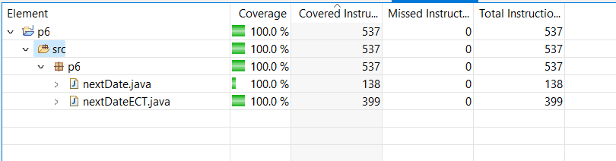

RESULT & DISCUSSION

Thus, the above programs are written and executed using JUnit and ECLEMMA, and 100% coverage is achieved.
Ex. No.: 7) DEMONSTRATION OF SELENIUM IDE FOR CONDUCTING TEST ON WEBSITE(S)
Date :

Designing Test Cases using Selenium IDE.

IMPLEMENTATION

Installing Selenium IDE

Step 1: Using Firefox, first, download the IDE from the SeleniumHQ downloads page.

Step 2: Firefox will protect you from installing add-ons from unfamiliar locations, so you will need to click ‘Allow’ to proceed with the installation, as shown in the following screenshot.

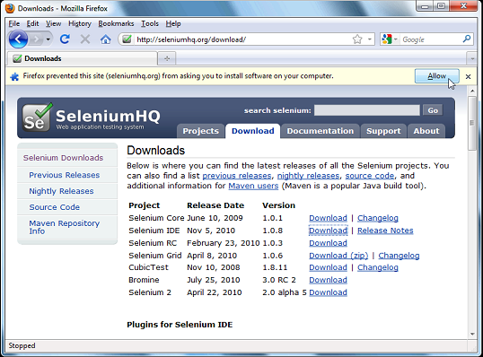

Step 3: Select Install Now. The Firefox Add-ons window pops up, first showing a progress bar, and when the download is complete, displays the following.

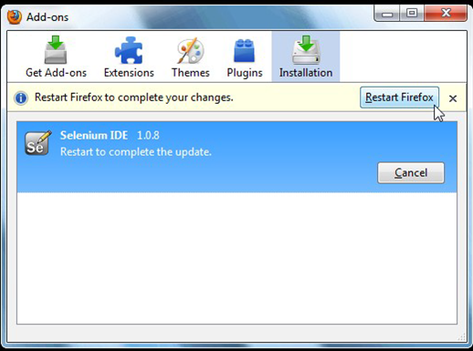

Step 4: Restart Firefox. After Firefox reboots you will find the Selenium-IDE listed under the Firefox Tools menu.

TEST CASES

TC’S #1: Manual Steps:
- Open (Example: Type www.google.com)
- Type “Software Te sting” in the Google Search Input Box
- Click outside on an empty spot
- Click Search Button
- Verify the Text Present as “Software Testing”
- Assert the Title as “Software Testing”
- Save the test case with .HTML Extension.

EXECUTION

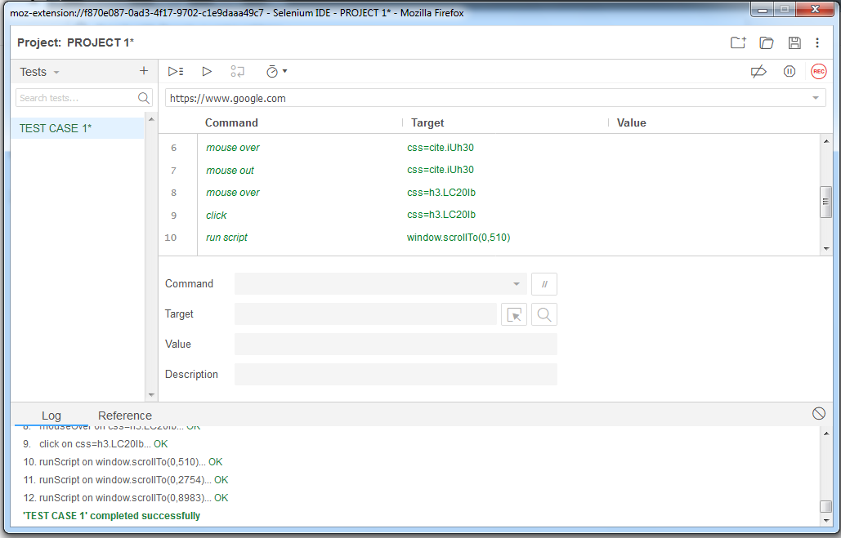

RESULT:

Thus, the demonstration of Selenium IDE for conducting test on a website is done successfully.

Ex. No.: 8) DEMONSTRATION OF SELENIUM WEBDRIVER FOR CONDUCTING TEST ON WEBSITE(S)
Date :

Write an automated selenium script to login into a web page by using Selenium Web driver, automate any website using Java Script.

IMPLEMENTATION

INSTALLATION

Step 1: Download the Selenium Server Standalone as follows:
https://www.seleniumhq.org/download/ → Latest Release: ChromeDriver 2.43 →
Selenium Server Standalone.
Step 2: Download Selenium Web Driver from https://www.seleniumhq.org/download/ →
Third Party Browser Drivers not developed by seleniumhq → Google Chrome Driver
Step 3: Extract the jar file of Selenium Server Standalone and add it to the project (eclipse)
created as follows: Right Click on the Project → Build Path → Configure Build Path →
Library (tab) → Add External Jar → Add the Selenium Server Standalone jar.

JAVA SCRIPT

import org.openqa.selenium.By;
import org.openqa.selenium.chrome.ChromeDriver;
import org.openqa.selenium.By;
import org.openqa.selenium.WebDriver;
import org.openqa.selenium.WebElement;
import org.openqa.selenium.chrome.ChromeDriver;
public class exp8 {
public static void main(String[] args) {
System.setProperty("webdriver.chrome.driver","C:\\Users\\ankit\\Downloads\\chromedriver_win32\\chromedriver.exe");System.setProperty("webdriver.chrome.driver","C:\\Users\\ankit\\Downloads\\chromedriver_win32\\chromedriver.exe");
WebDriver driver = new ChromeDriver();
driver.get("C:\\Users\\ankit\\Downloads\\login.html");
driver.manage().window().maximize();
System.out.println("1NH18CS706 Ankit Datta");
WebElement email = driver.findElement(By.name("username"));
email.sendKeys("mercury");
WebElement password = driver.findElement(By.name("password"));
password.sendKeys("password");
WebElement login = driver.findElement(By.name("submit"));
login.click();
}
}

EXECUTION

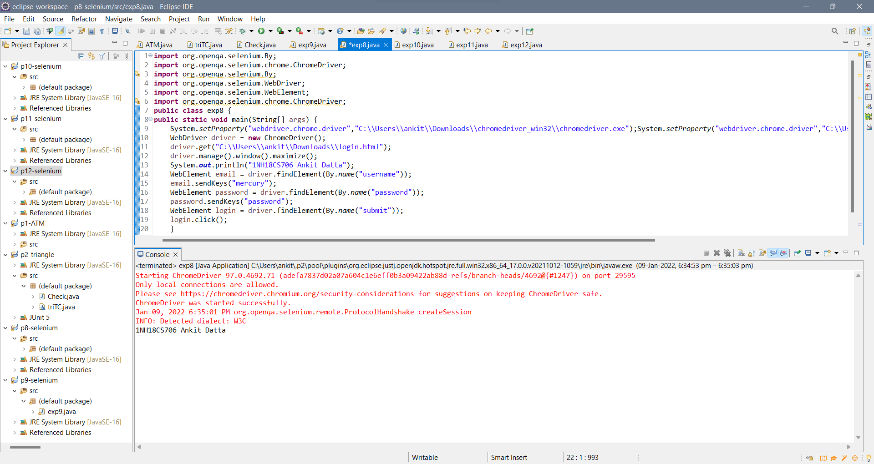

RESULT:
Thus, the above program is written and executed using selenium web driver.
Ex. No.: 9) DEMONSTRATION OF SELENIUM WEBDRIVER FOR CONDUCTING TEST ON WEBSITE(S)
Date :

Write an automated selenium script to list the total number of objects present on a web page.

IMPLEMENTATION

INSTALLATION

Step 1: Download the Selenium Server Standalone as follows:
https://www.seleniumhq.org/download/ → Latest Release: ChromeDriver 2.43 →
Selenium Server Standalone.
Step 2: Download Selenium Web Driver from https://www.seleniumhq.org/download/ →
Third Party Browser Drivers not developed by seleniumhq → Google Chrome Driver
Step 3: Extract the jar file of Selenium Server Standalone and add it to the project (eclipse)
created as follows: Right Click on the Project → Build Path → Configure Build Path →
Library (tab) → Add External Jar → Add the Selenium Server Standalone jar.

JAVA SCRIPT

import org.openqa.selenium.chrome.ChromeDriver;
public class exp10 {
public static void main(String[] args){
System.setProperty("webdriver.chrome.driver","C:\\Users\\ankit\\Downloads\\chromedriver_win32\\chromedriver.exe");
ChromeDriver driver = new ChromeDriver();
driver.get("http:\\google.com");
System.out.println("1NH18CS706 Ankit Datta");
driver.manage().window().maximize();
String str=driver.getTitle();
String str1=driver.getCurrentUrl();
System.out.println("The Title of webpage is "+ str+" ");
if(str.equals("Google"))
System.out.println(true);
else System.out.println(false);
System.out.println("The Link of webpage is "+ str1+" ");
if(str1.equals("https://www.google.com/?gws_rd=ssl"))
System.out.println(true);
else
System.out.println(false);
}
}

EXECUTION

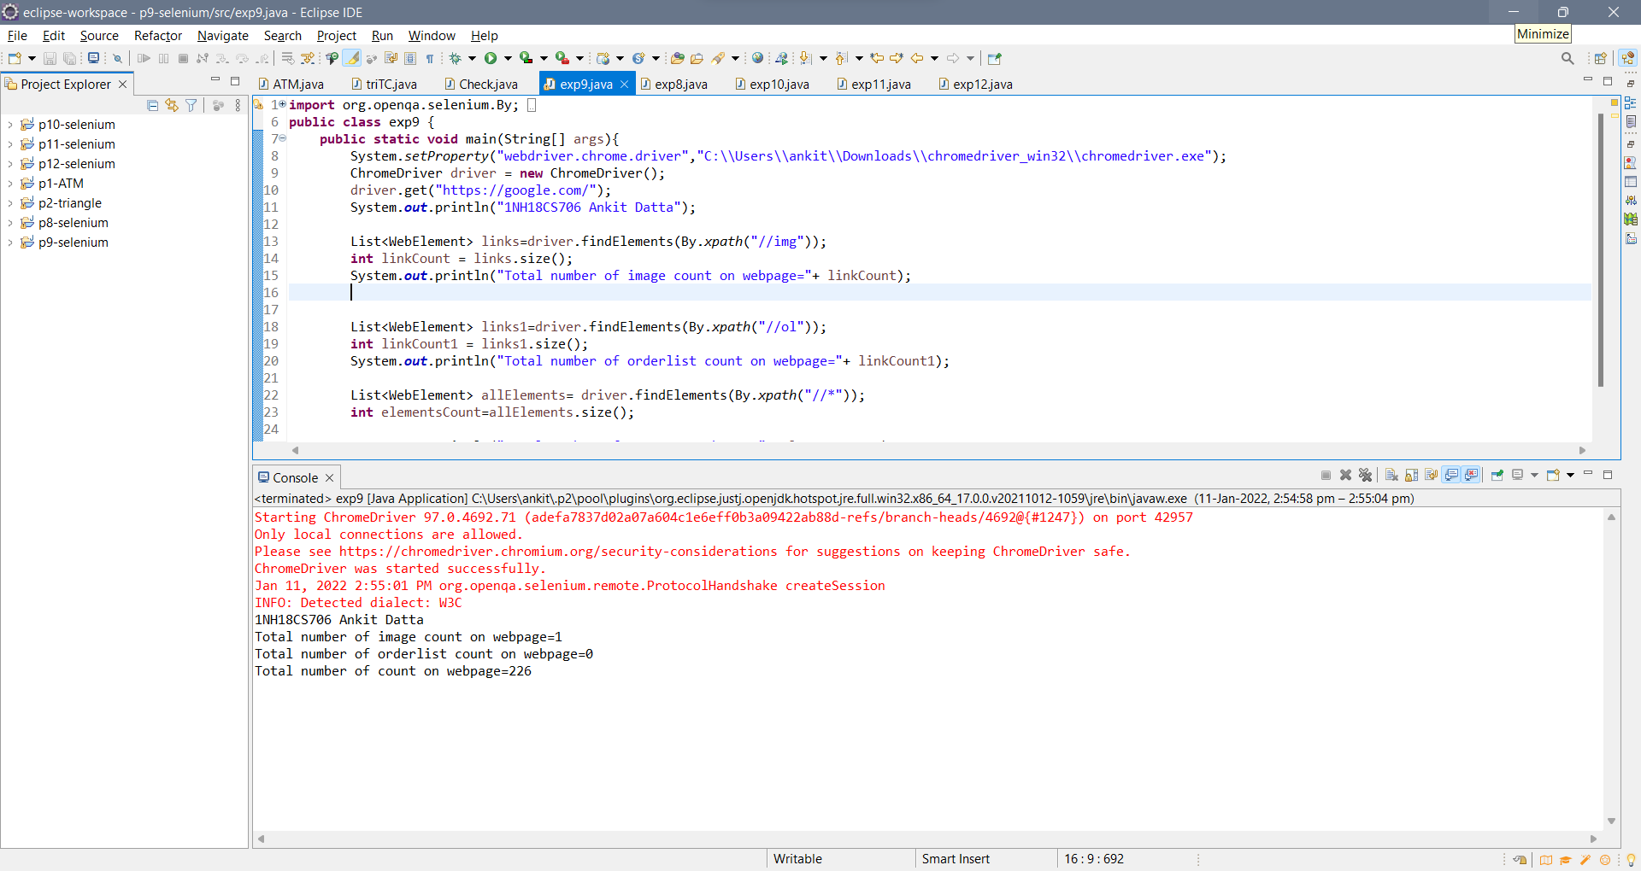

RESULT:
Thus, the above program is written and executed using selenium web driver.
Ex. No.: 10) DEMONSTRATION OF SELENIUM WEBDRIVER FOR CONDUCTING TEST ON WEBSITE(S)
Date :

Write an automated selenium script to demonstrate URL and Title check point

IMPLEMENTATION

INSTALLATION

Step 1: Download the Selenium Server Standalone as follows:
https://www.seleniumhq.org/download/ → Latest Release: ChromeDriver 2.43 →
Selenium Server Standalone.
Step 2: Download Selenium Web Driver from https://www.seleniumhq.org/download/ →
Third Party Browser Drivers not developed by seleniumhq → Google Chrome Driver
Step 3: Extract the jar file of Selenium Server Standalone and add it to the project (eclipse)
created as follows: Right Click on the Project → Build Path → Configure Build Path →
Library (tab) → Add External Jar → Add the Selenium Server Standalone jar.

JAVA SCRIPT

import java.util.List;
import org.openqa.selenium.By;
import org.openqa.selenium.WebDriver;
import org.openqa.selenium.WebElement;
import org.openqa.selenium.chrome.ChromeDriver;
import org.openqa.selenium.support.ui.Select;
public class exp11 {
public static void main(String[] args) throws InterruptedException {
System.setProperty("webdriver.chrome.driver","C:\\Users\\ankit\\Downloads\\chromedriver_win32\\chromedriver.exe");
WebDriver driver = new ChromeDriver();
driver.get("https://demoqa.com/select-menu");
driver.manage().window().maximize();
System.out.println("1NH18CS706 Ankit Datta");
Select select = new Select(driver.findElement(By.id("cars")));
System.out.println("The dropdown options are -");
List<WebElement> options = select.getOptions();
for(WebElement option: options)
System.out.println(option.getText());
if(select.isMultiple()){
System.out.println("Select option 'Opel' by Index");
select.selectByIndex(2);
Thread.sleep(5000);
System.out.println("Select option 'Saab' by Value");
select.selectByValue("saab");
Thread.sleep(5000);
System.out.println("Select option 'Audi' by Text");
select.selectByVisibleText("Audi");
Thread.sleep(5000);
System.out.println("The selected values in the dropdown options are -");
List<WebElement> selectedOptions = select.getAllSelectedOptions();
for(WebElement selectedOption: selectedOptions)
System.out.println(selectedOption.getText());
System.out.println("Deselect option 'Audi' by Index");
select.deselectByIndex(3);
Thread.sleep(5000);
System.out.println("Deselect option 'Opel' by Text");
select.deselectByVisibleText("Opel");
System.out.println("The selected values after deselect in the dropdown options are -");
List<WebElement> selectedOptionsAfterDeselect = select.getAllSelectedOptions();
for(WebElement selectedOptionAfterDeselect: selectedOptionsAfterDeselect)
System.out.println(selectedOptionAfterDeselect.getText());
select.deselectAll();
}
driver.quit();
}
}

EXECUTION

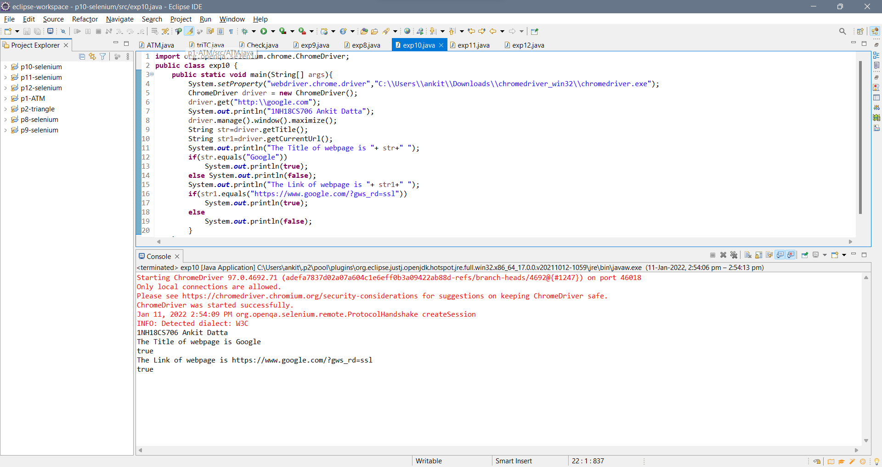
RESULT:
Thus, the above program is written and executed using selenium web driver.
Ex. No.: 11) DEMONSTRATION OF SELENIUM WEBDRIVER FOR CONDUCTING TEST ON WEBSITE(S)
Date :

Write an automated selenium script to demonstrate selecting and deselecting options from multi select dropdown

IMPLEMENTATION

INSTALLATION

Step 1: Download the Selenium Server Standalone as follows:
https://www.seleniumhq.org/download/ → Latest Release: ChromeDriver 2.43 →
Selenium Server Standalone.
Step 2: Download Selenium Web Driver from https://www.seleniumhq.org/download/ →
Third Party Browser Drivers not developed by seleniumhq → Google Chrome Driver
Step 3: Extract the jar file of Selenium Server Standalone and add it to the project (eclipse)
created as follows: Right Click on the Project → Build Path → Configure Build Path →
Library (tab) → Add External Jar → Add the Selenium Server Standalone jar.

JAVA SCRIPT

import java.util.List;
import org.openqa.selenium.By;
import org.openqa.selenium.WebDriver;
import org.openqa.selenium.WebElement;
import org.openqa.selenium.chrome.ChromeDriver;
import org.openqa.selenium.support.ui.Select;
public class exp11 {
public static void main(String[] args) throws InterruptedException {
System.setProperty("webdriver.chrome.driver","C:\\Users\\ankit\\Downloads\\chromedriver_win32\\chromedriver.exe");
WebDriver driver = new ChromeDriver();
driver.get("https://demoqa.com/select-menu");
driver.manage().window().maximize();
System.out.println("1NH18CS706 Ankit Datta");
Select select = new Select(driver.findElement(By.id("cars")));
System.out.println("The dropdown options are -");
List<WebElement> options = select.getOptions();
for(WebElement option: options)
System.out.println(option.getText());
if(select.isMultiple()){
System.out.println("Select option 'Opel' by Index");
select.selectByIndex(2);
Thread.sleep(5000);
System.out.println("Select option 'Saab' by Value");
select.selectByValue("saab");
Thread.sleep(5000);
System.out.println("Select option 'Audi' by Text");
select.selectByVisibleText("Audi");
Thread.sleep(5000);
System.out.println("The selected values in the dropdown options are -");
List<WebElement> selectedOptions = select.getAllSelectedOptions();
for(WebElement selectedOption: selectedOptions)
System.out.println(selectedOption.getText());
System.out.println("Deselect option 'Audi' by Index");
select.deselectByIndex(3);
Thread.sleep(5000);
System.out.println("Deselect option 'Opel' by Text");
select.deselectByVisibleText("Opel");
System.out.println("The selected values after deselect in the dropdown options are -");
List<WebElement> selectedOptionsAfterDeselect = select.getAllSelectedOptions();
for(WebElement selectedOptionAfterDeselect: selectedOptionsAfterDeselect)
System.out.println(selectedOptionAfterDeselect.getText());
select.deselectAll();
}
driver.quit();
}
}

EXECUTION

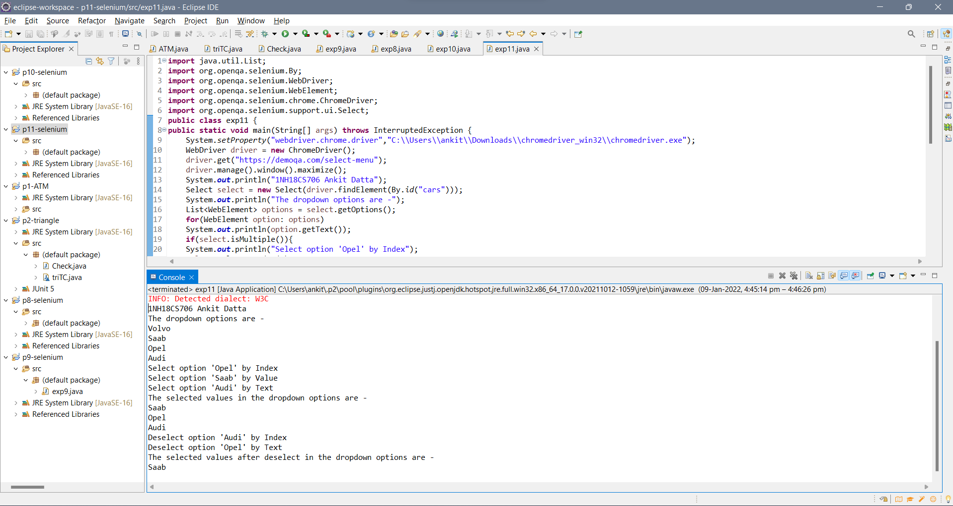

RESULT:
Thus, the above program is written and executed using selenium web driver.
Ex. No.: 12) DEMONSTRATION OF SELENIUM WEBDRIVER FOR CONDUCTING
TEST ON WEBSITE(S)
Date :

Write an automated selenium script to demonstrate Synchronization.

IMPLEMENTATION

INSTALLATION

Step 1: Download the Selenium Server Standalone as follows:
https://www.seleniumhq.org/download/ → Latest Release: ChromeDriver 2.43 →
Selenium Server Standalone.
Step 2: Download Selenium Web Driver from https://www.seleniumhq.org/download/ →
Third Party Browser Drivers not developed by seleniumhq → Google Chrome Driver
Step 3: Extract the jar file of Selenium Server Standalone and add it to the project (eclipse)
created as follows: Right Click on the Project → Build Path → Configure Build Path →
Library (tab) → Add External Jar → Add the Selenium Server Standalone jar.

JAVA SCRIPT

import java.util.concurrent.TimeUnit;
import org.openqa.selenium.By;
import org.openqa.selenium.WebDriver;
import org.openqa.selenium.chrome.ChromeDriver;
public class exp12 {
public static void main(String[] args) throws InterruptedException {
System.setProperty("webdriver.chrome.driver","C:\\Users\\ankit\\Downloads\\chromedriver_win32\\chromedriver.exe");
ChromeDriver driver = new ChromeDriver();
System.out.println("1NH18CS706 Ankit Datta");
driver.manage().timeouts().implicitlyWait(10,TimeUnit.MINUTES) ;
String eTitle = "Demo Guru99 Page";
String aTitle = "" ;
driver.get("http://demo.guru99.com/test/guru99home/" );
driver.manage().window().maximize() ;
aTitle = driver.getTitle();
if (aTitle.equals(eTitle)){
System.out.println( "Test Passed") ;
}
else {
System.out.println( "Test Failed" );
}
driver.close();
}
}
EXECUTION

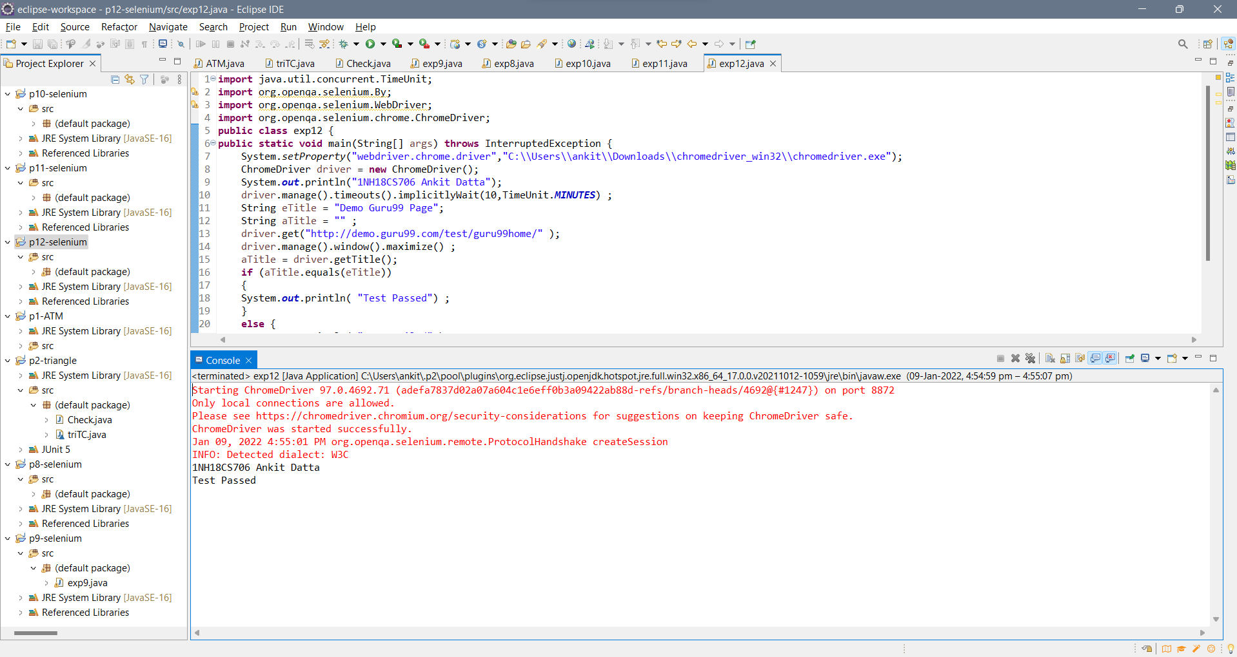

RESULT:

Thus, the above program is written and executed using selenium web driver.

